

Practices for Secure Software Report

Table of Contents
Document Revision History 3
Client 3
Instructions 3
Developer 4
1. Algorithm Cipher 4
2. Certificate Generation 4
3. Deploy Cipher 4
4. Secure Communications 4
5. Secondary Testing 4
6. Functional Testing 4
7. Summary 4
8. Industry Standard Best Practices 4

Document Revision History

Version | Date | Author | Comments
1.0 |  | Kameron Woods

Client



Instructions

Submit this completed practices for secure software report. Replace the bracketed text with the relevant information. You must document your process for writing secure communications and refactoring code that complies with software security testing protocols.

- Respond to the steps outlined below and include your findings.
- Respond using your own words. You may also choose to include images or supporting materials. If you include them, make certain to insert them in all the relevant locations in the document.
- Refer to the Project Two Guidelines and Rubric for more detailed instructions about each section of the template.

Developer
Kameron Woods

Algorithm Cipher
I have determined that Advanced Encryption Standard or (AES) would be the best encryption cipher for Artemis Financial’s needs. AES works by taking 16 bytes of plain text data that needs to be encrypted and lays it out in a 4x4 grid. This grid is then put through several rounds of transformations such as substitution, row shifting, column mixing, and round key additions. Because AES uses symmetric encryption with the same secret key that encrypts the data also decrypts it, without the key there is no way to decrypt the data. There are no known direct weaknesses with AES being theoretically impossible to crack with brute force in a single lifetime.
The bit levels of AES determine the key size in bits the more bits you use the more secure it is. Depending on the type of key used determines the number of rounds the transformations are done 128-bit keys do 10 rounds, 192-bit keys do 12 rounds, and 256-bit keys do 14 rounds of transformations. I would recommend using the 256-bit key for maximum security. When it comes to hash functions I would recommend using SHA-256 hash functions to serve as a one-way operation to verify integrity of data.
AES uses a symmetric key meaning a single key is used to both encrypt and decrypt data. The sender of data and receiver of data must have the same key to interpret data. Random numbers is a key component of AES to create a cryptographic key that is not possible to predict or decipher keys.
AES was adopted to phase out DES, the former standard for encryption when vulnerabilities were discovered. 24 years later and AES is still the industry standard for most of all encryptions in The United States with no signs of any vulnerabilities being discovered soon. With AES the only risk is improper implementation which means if done correctly any encrypted information will stay safe. With the use of AES Artemis Financial will be able to boost security, comply with government regulations, and block all risks that come with unauthorized access to sensitive information.

Certificate Generation
Insert a screenshot below of the CER file.

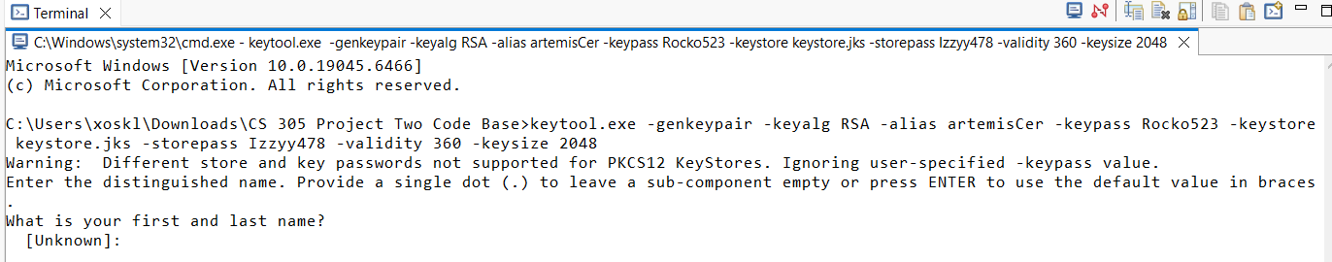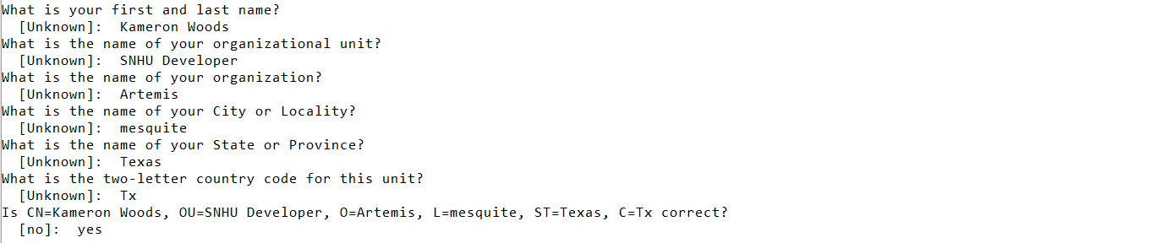
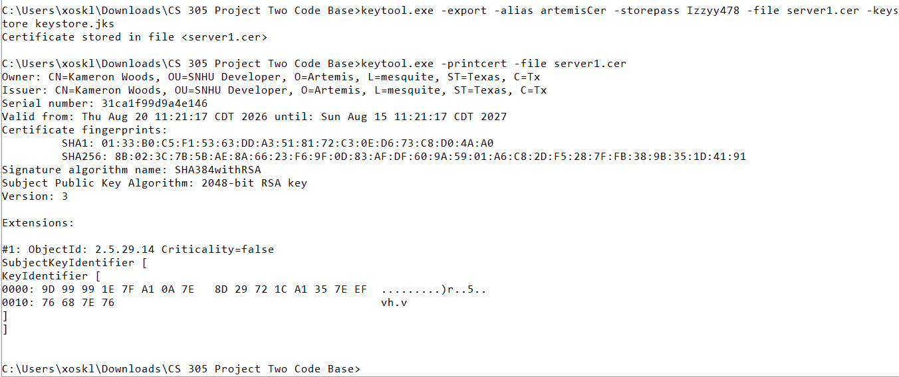

Deploy Cipher
Insert a screenshot below of the checksum verification.
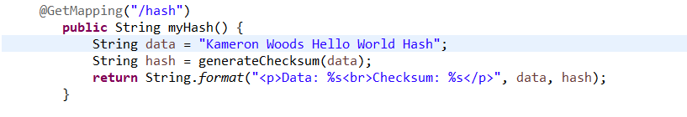

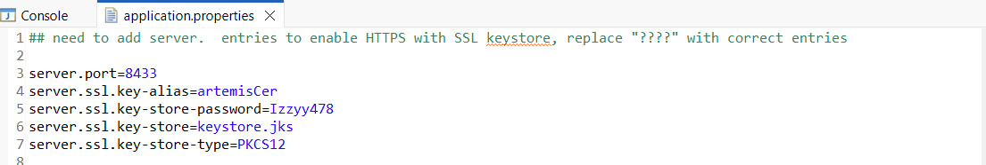
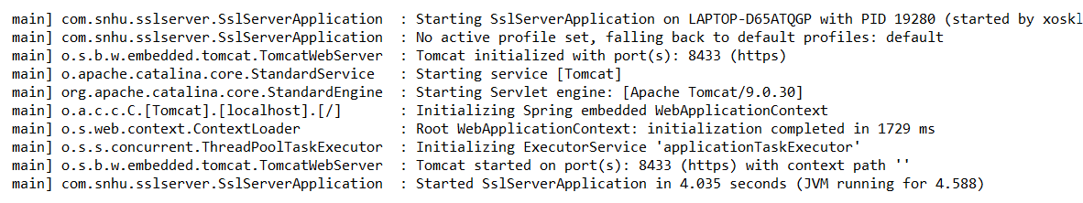

Data through checksum verification has not been altered or corrupted. I verified the integrity of the data.

Secure Communications
Insert a screenshot below of the web browser that shows a secure webpage.

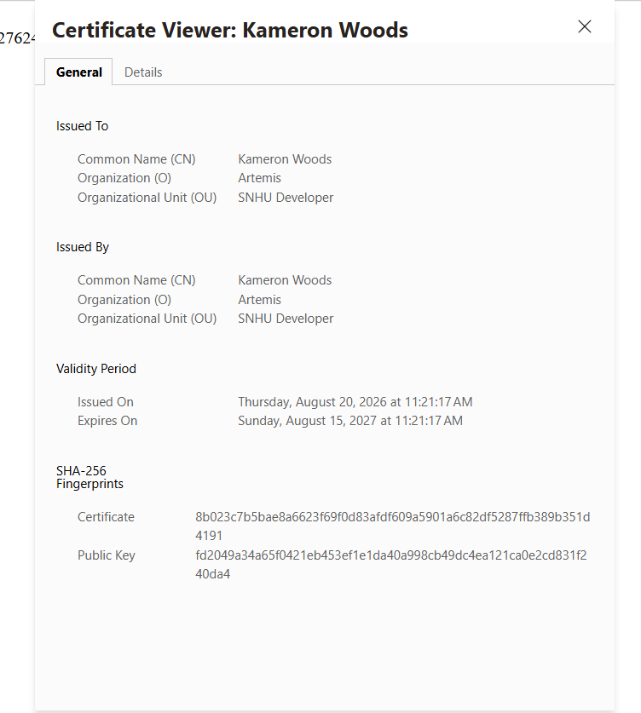

Secondary Testing
Insert screenshots below of the refactored code executed without errors and the dependency-check report.

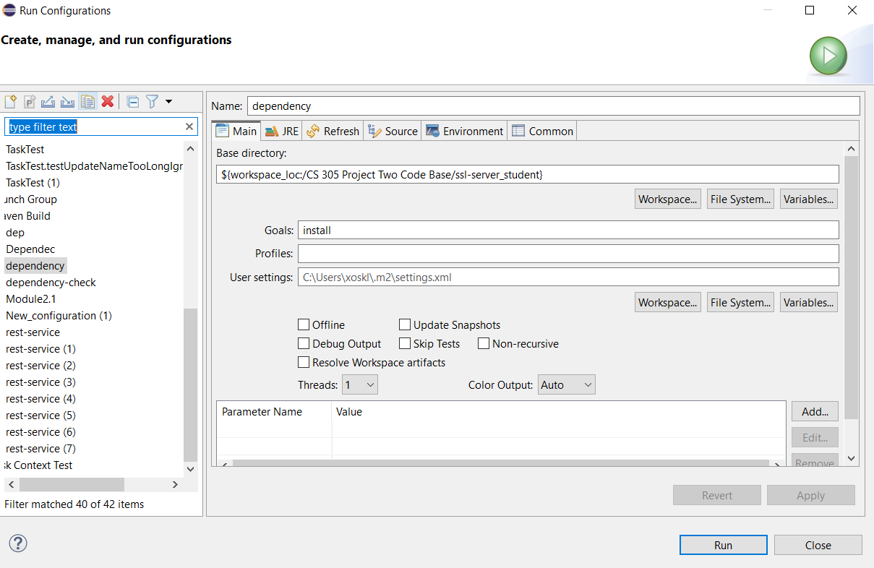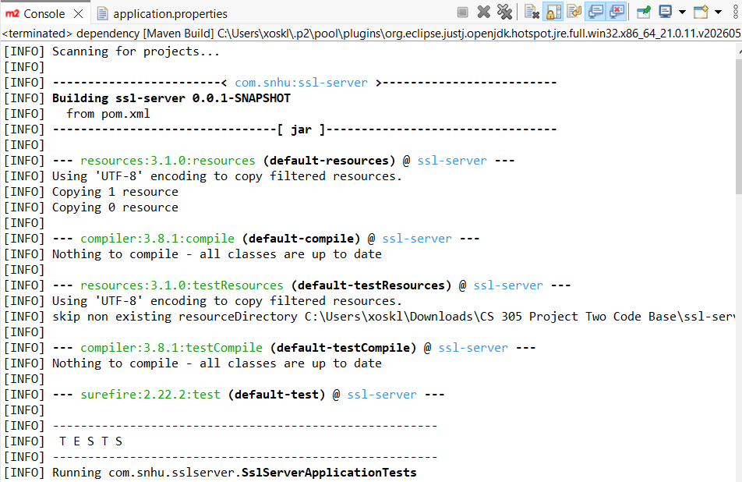
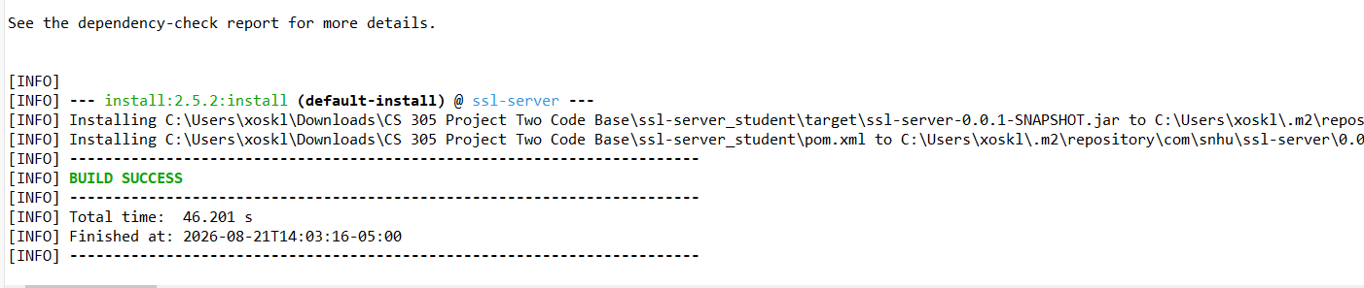
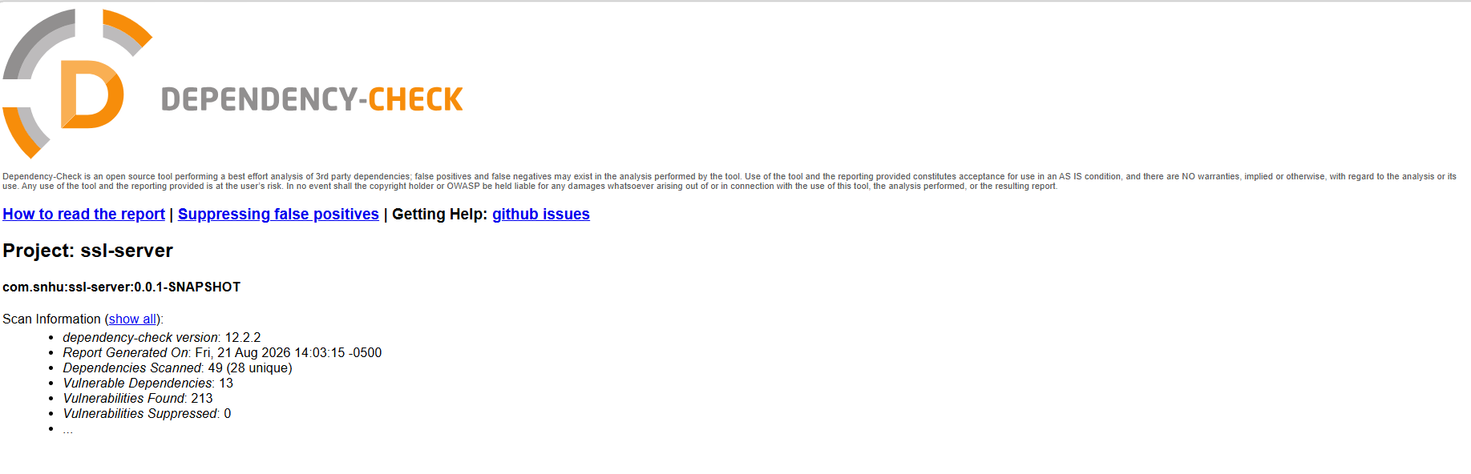
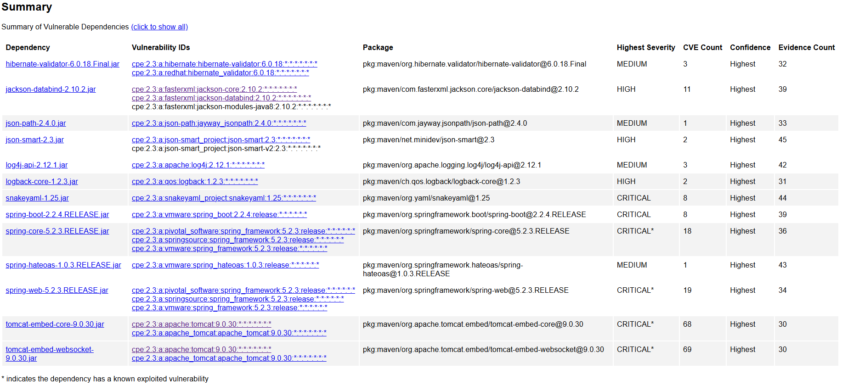
Below is the link to my dependency check
file:///C:/Users/xoskl/Downloads/CS%20305%20Project%20Two%20Code%20Base/ssl-server_student/target/dependency-check-report.html

Functional Testing
Insert a screenshot below of the refactored code executed without errors.

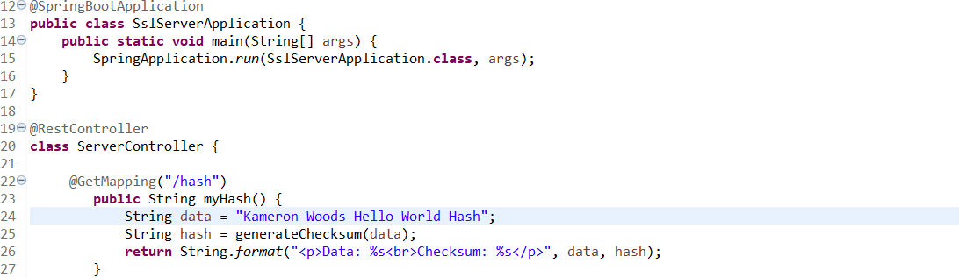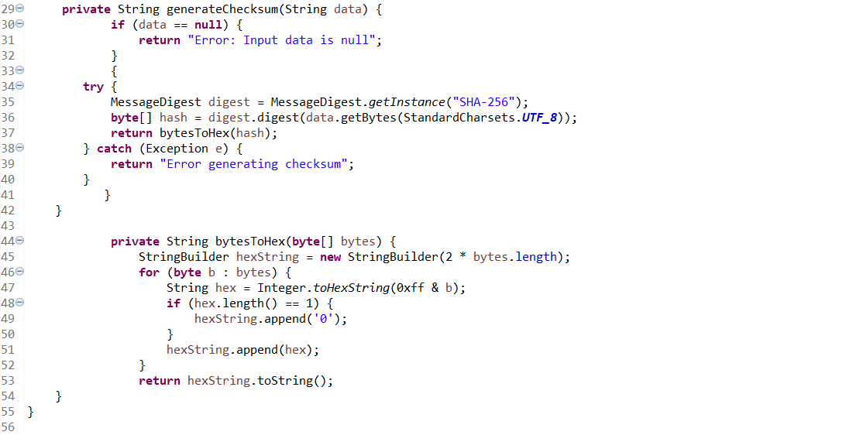


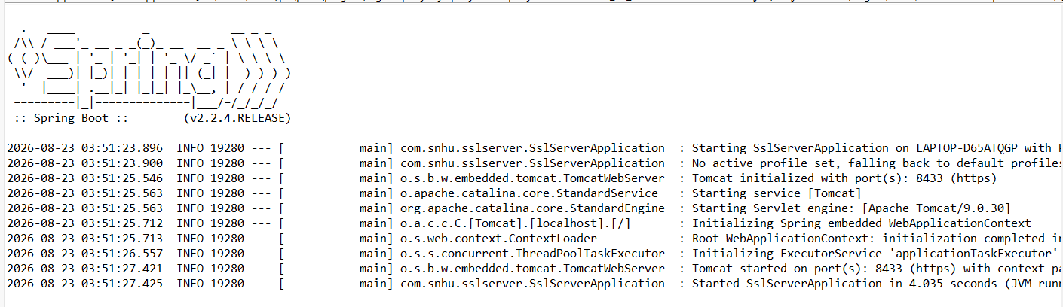

Summary
When refactoring the code I first started by creating a @RestController which tells Spring Boot to create a web controller that handles incoming internet requests and sends data. I added a Spring Boot controller method that creates an HTTP endpoint at the URL path /hash which creates a checksum for text strings. I also refactored the code to generate a SHA-256 hash to a piece of text and converts the bytes into a readable hex string. I also ran an updated version of the dependency-check tool ensure no extra vulnerabilities were added.

Industry Standard Best Practices

To apply industry standard best practices, I first implemented secure code. I also updated versions of plugins withing the pom.xml file such as the dependency check. By doing this I ensure that I am using patched tools which could free up vulnerabilities.
To further ensure industry standards, I would like to apply input validation to prevent cyber-attacks, authentication to improve proper access and permissions, and proper error handling to stop any potential security threats and info leaks.
By using industry standard best practices, a program can be enhanced for quality, efficiency, and reliability. These are great for reducing errors, ensuring stability of code, and improving safety.

